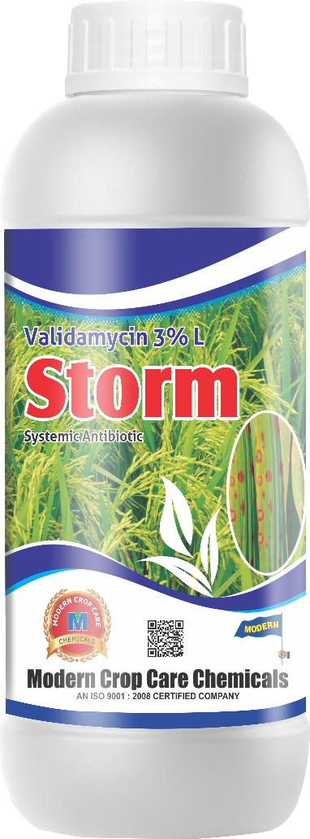
Product Name :- STORM
Technical Name :- Validamycin 3% L
Description :- Storm (Validamycin 3% L) is an antibiotic fungicide which controls Sheath blight disease of Rice very effectively. It acts on hyphae and destroys the fungus by its contact action and controls the spread of diseases. STORM is also most effective against soil borne diseases and used for the control of Rhizoctonia solani in rice.
Packing :- 1ltr
Crops :- Rice
Disease/Pests :- Sheath Blight

